**IFRS16 - Leases**

**Required files** (*SOX screenshots will be taken as evidence for all exports)*:

# S_ALR_87011990 (Asset history): this ECC transaction supplies all the assets owned by a company.

* **FAGLL03** downloads for the below accounts:
* **Liability extract:**

2003102000 - Finance Lease - Interest Accrued External

2000106000 - Finance Lease - Principal - External <1yr (Adj)

2010105000 - Finance Lease - Principal External >1yr

2010108000 - Finance Lease - Principal Interest External >1yr

* **(Gains)/Losses on lease modifications/reassessment:**

5860106100 (Gains)/Losses on lease modifications/reassessment

* **Interest P&L**:

6001101100 – Interest expense

* **Acquisition account:**

1190102000 Acquisition Off Setting

* **An excel file** with the below sheets:
* Summary Pivots
* Evidence (prt screens with the downloads)
* Asset history
* Liability postings
* Gain/loss P&L
* interest P&L
* Acquisition account

# IFRS16 Downloads: How-to

1. **Asset history** (S_ALR_87011990) ECC transaction is run as per below example:

* Step 1: select Company code (TR10)
* Step 2: select Report date (31.12.2020)
* Step 3: select List assets
* Step 4: run the transaction

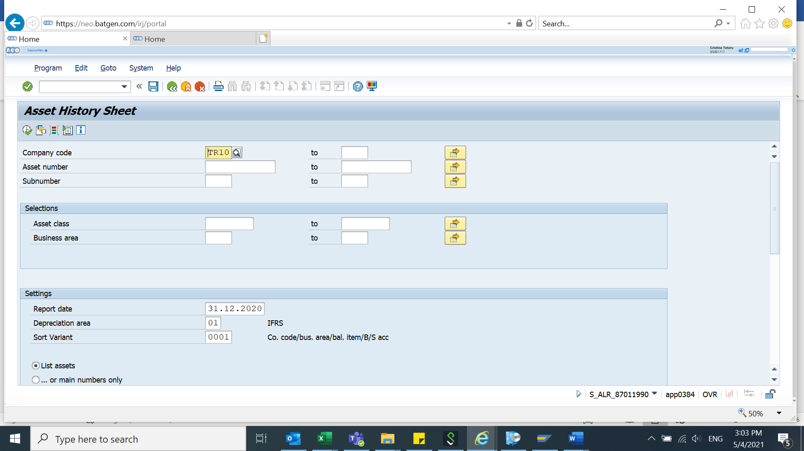

* Run the transaction:

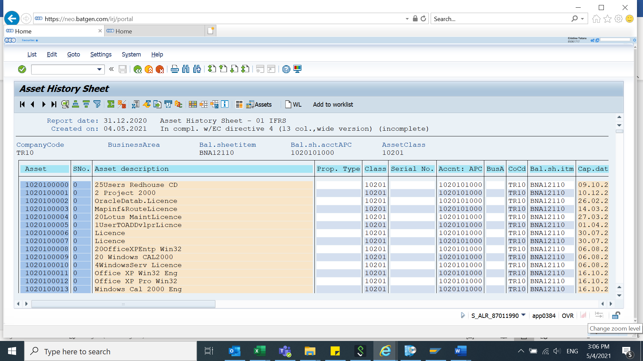

* And then export the results as per below:

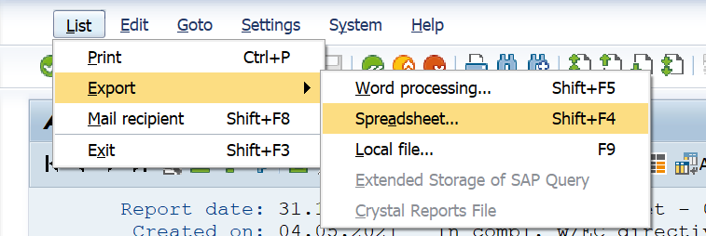

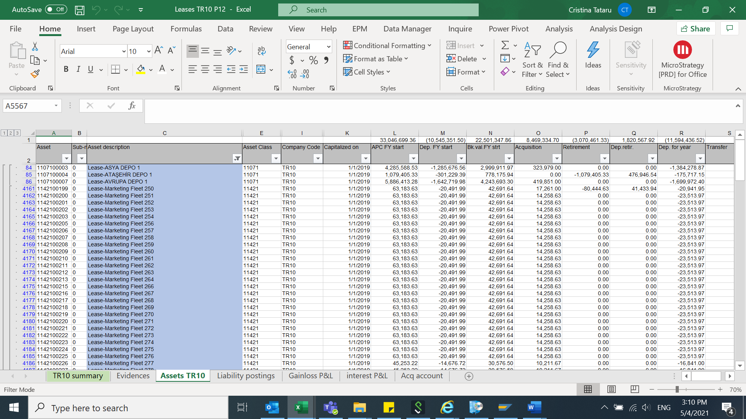

* After we will export the database, we will map the transactions based on ***Asset class*** in 3 categories: **improvements** (we need to exclude from Property column J Balance sheet item **BNA22210 Leasehold Buildings - Acquisition** what is IFRS16 assets and the remaining assets are improvements usually are under asset class 11091, 11081 and a part of 11071), **others** (asset class 11421,11431 and in asset description column we need to have the “lease” description) and **property** (11071).

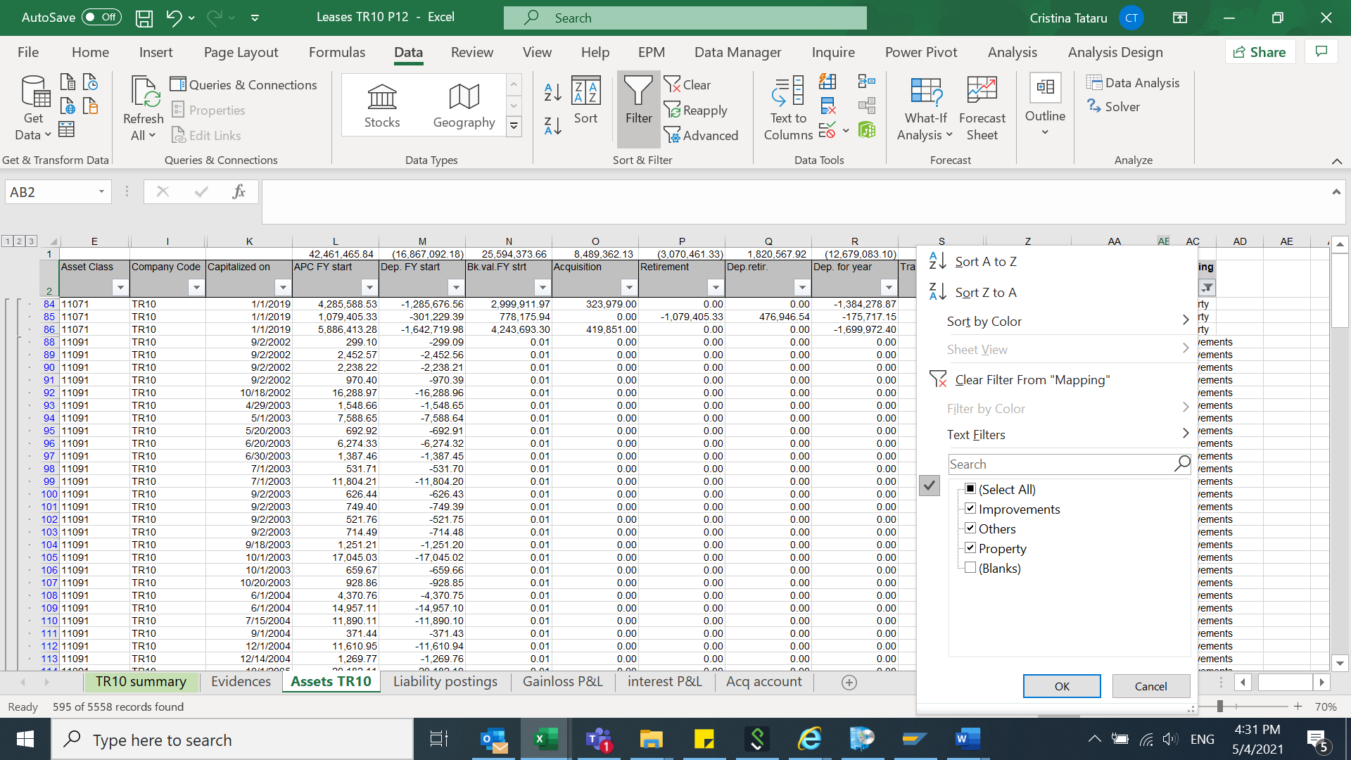

1. FAGLL03- **Liability extract**, ECC transaction is run as per below example:

* Step 1: select Company Code (TR10)
* Step 2: GL accounts:

2003102000 - Finance Lease - Interest Accrued External

2000106000 - Finance Lease - Principal - External <1yr (Adj)

2010105000 - Finance Lease - Principal External >1yr

2010108000 - Finance Lease - Principal Interest External >1yr

* Step 3: select period with All items (for 2020 will be 01.01.2020-31.12.2020)
* Step 4: select layout /DQI_EEMEA
* Step 5: run the transaction

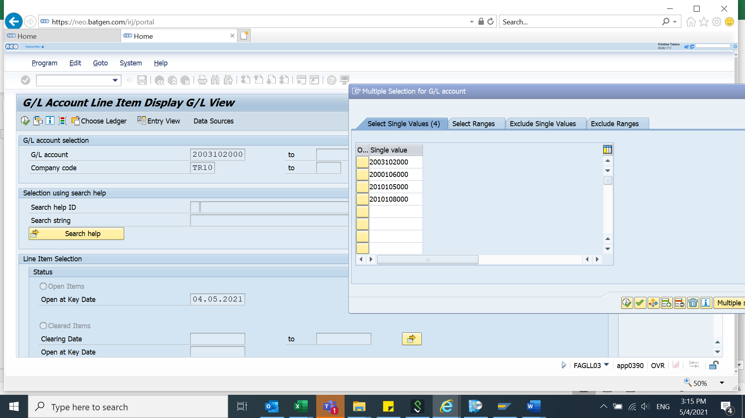

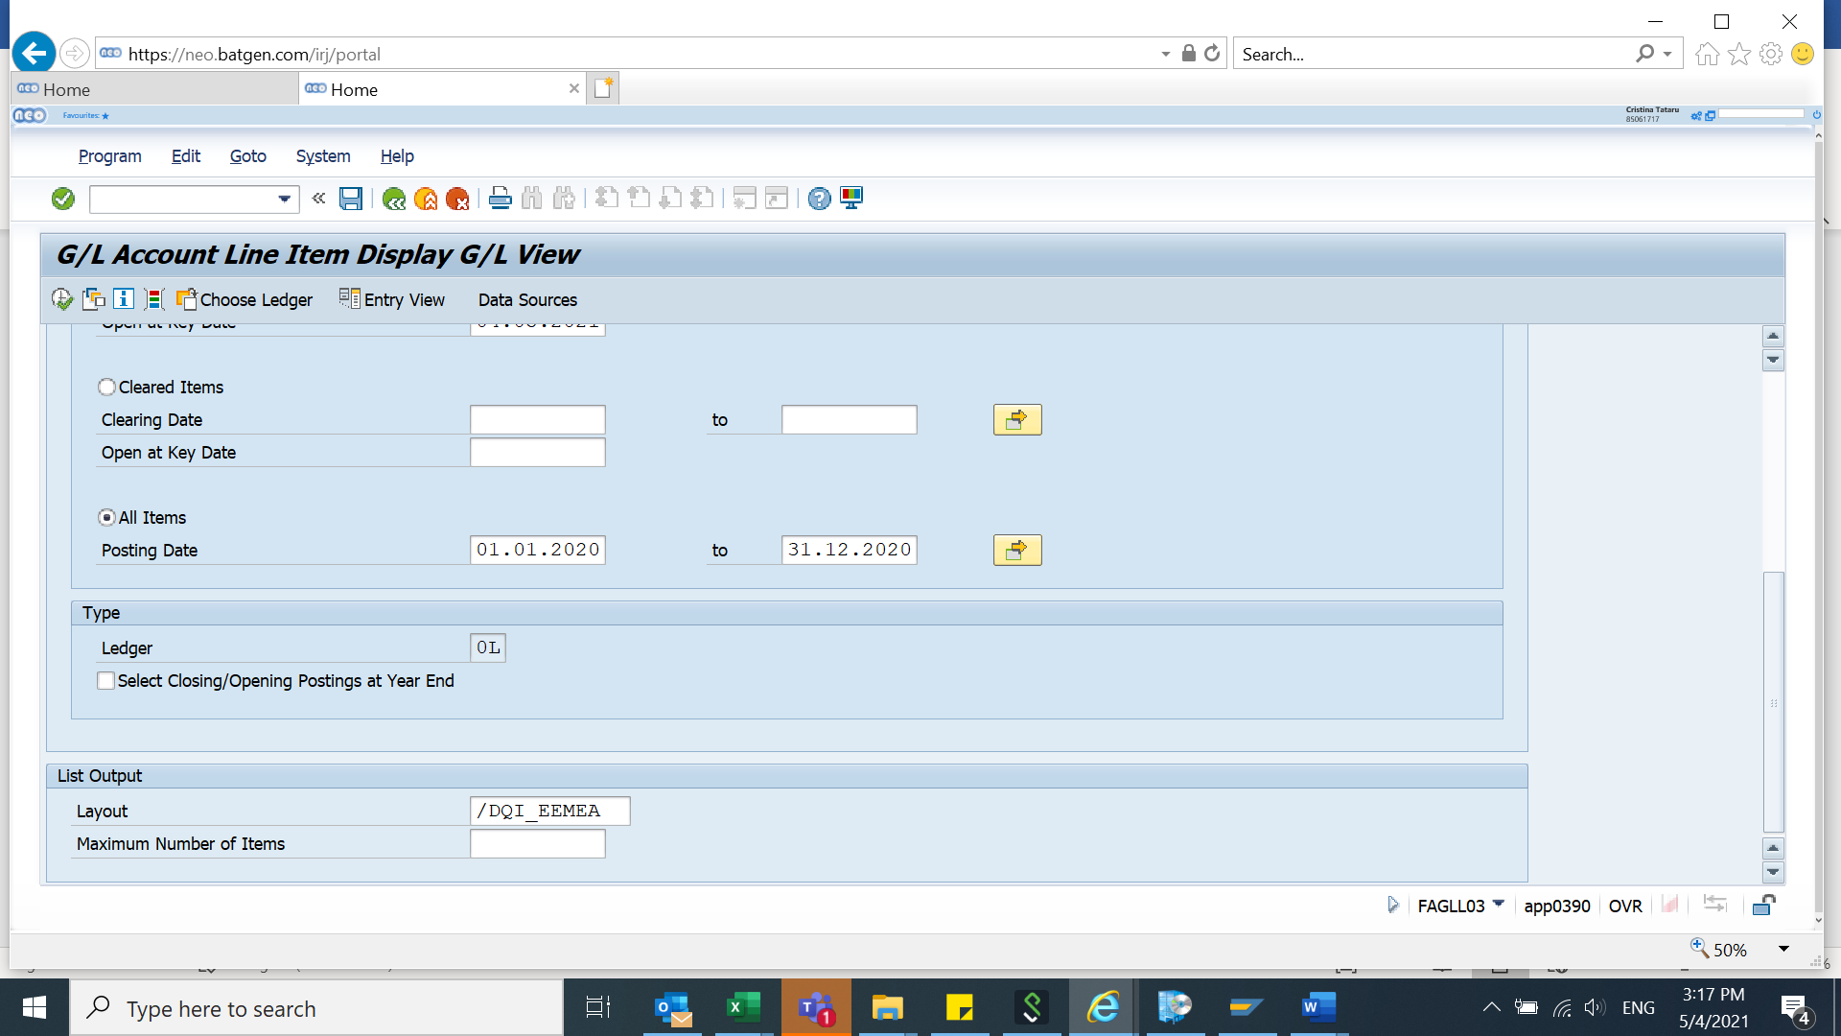

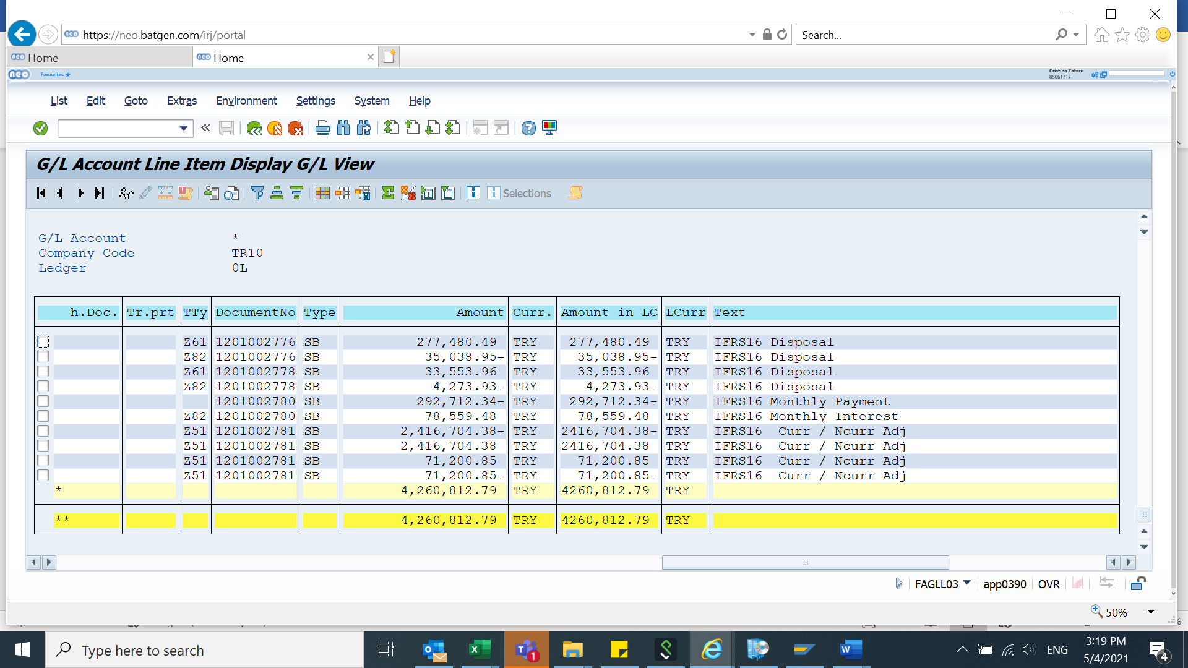

* Export the database in excel format:

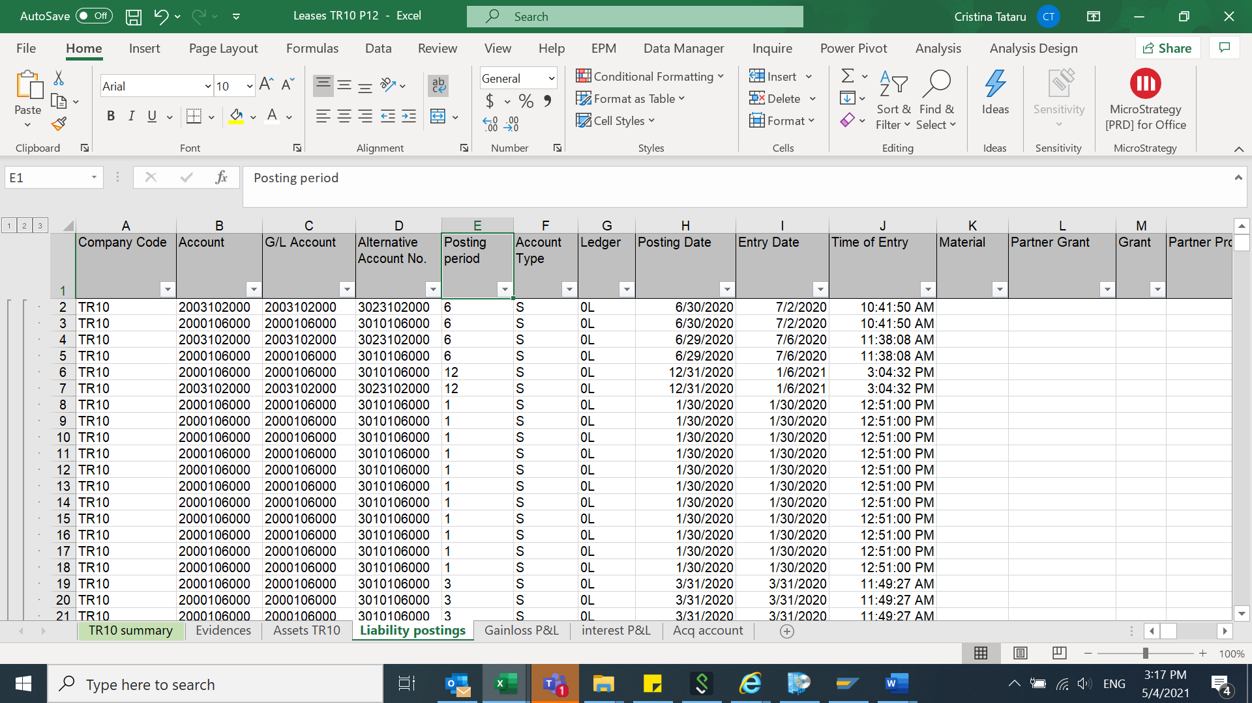

1. FAGLL03 - **(Gains)/Losses** on lease modifications/reassessment ECC transaction is run as per below example:

Step 1: select Company Code (TR10)

Step 2: GL account 5860106100 (Gains)/Losses on lease modifications/reassessment

Step 3: select period with All items (for 2020 will be 01.01.2020-31.12.2020)

Step 4: select layout /DQI_EEMEA

Step 5: run the transaction

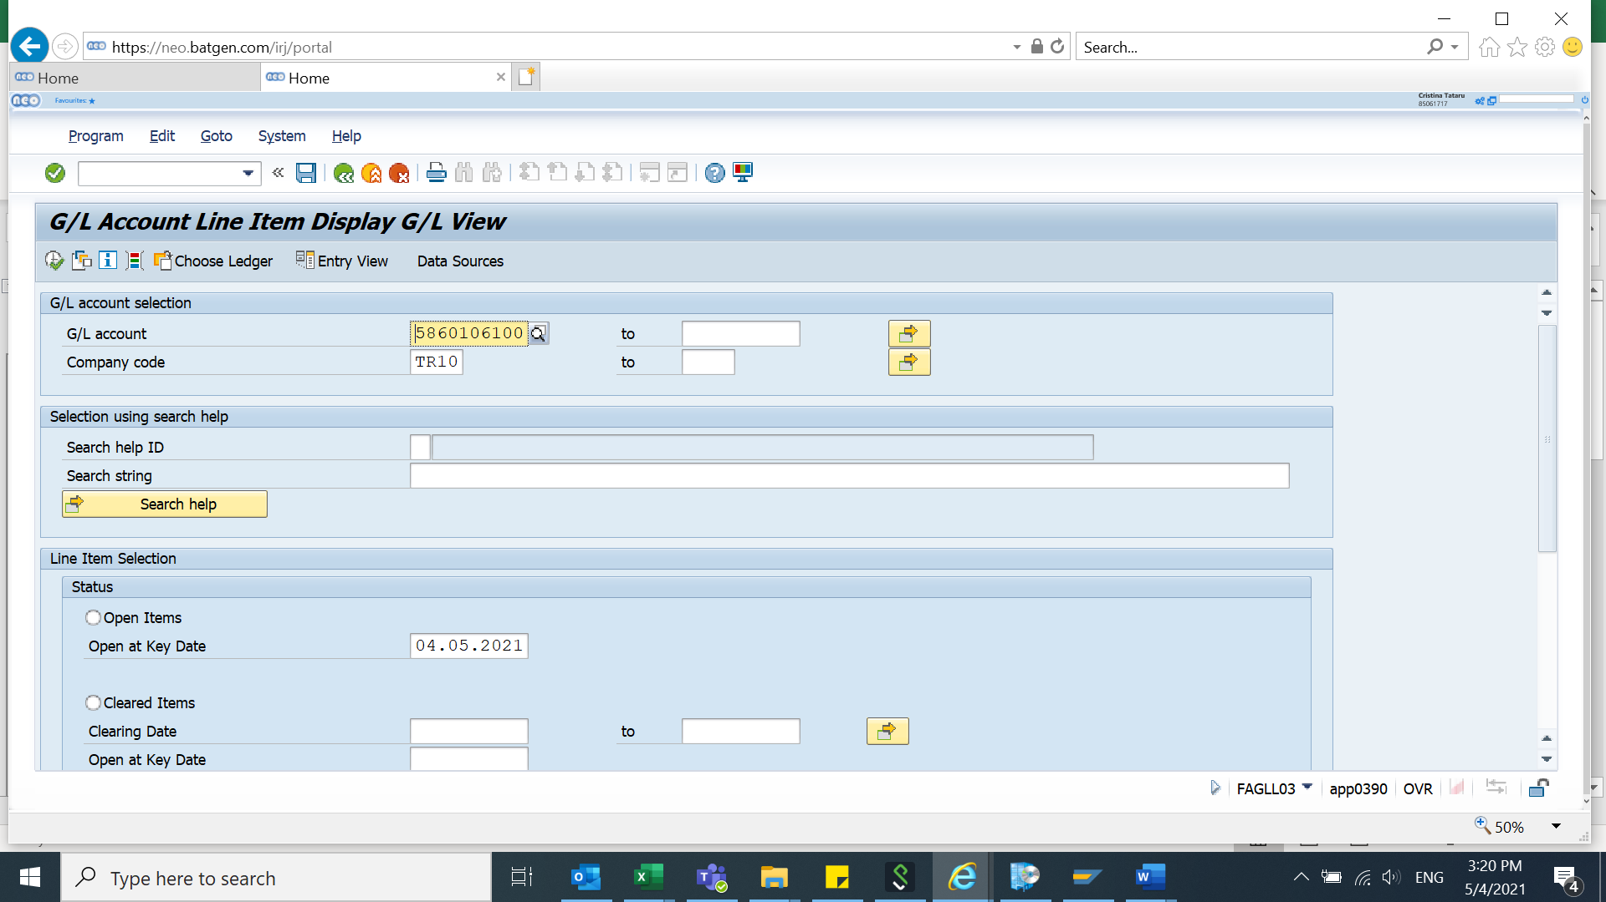



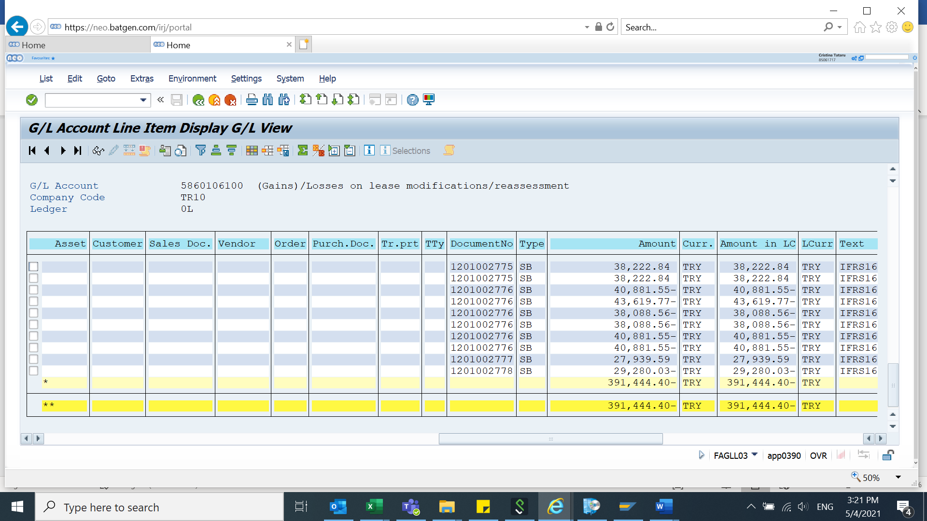

* Export the database in excel format:

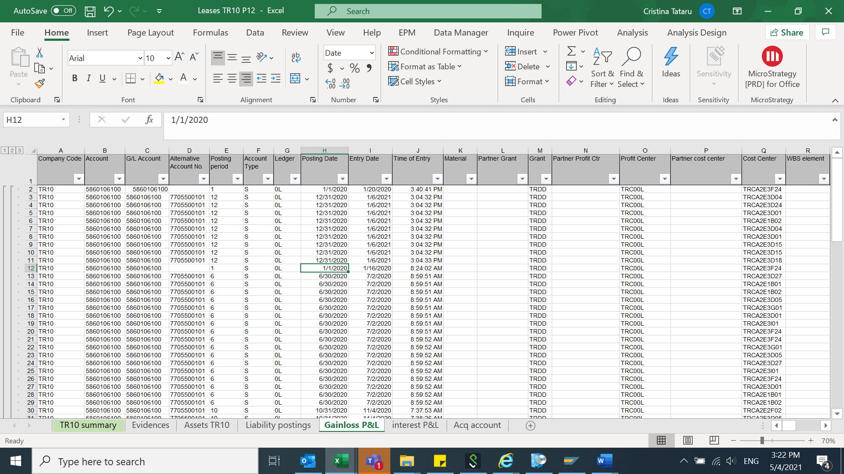

1. FAGLL03 **- Interest P&L** - ECC transaction is run as per below example:

Step 1: select Company Code (TR10)

Step 2: GL account 6001101100 – Interest expense

Step 3: select period with All items (for 2020 will be 01.01.2020-31.12.2020)

Step 4: select layout /DQI_EEMEA

Step 5: run the transaction

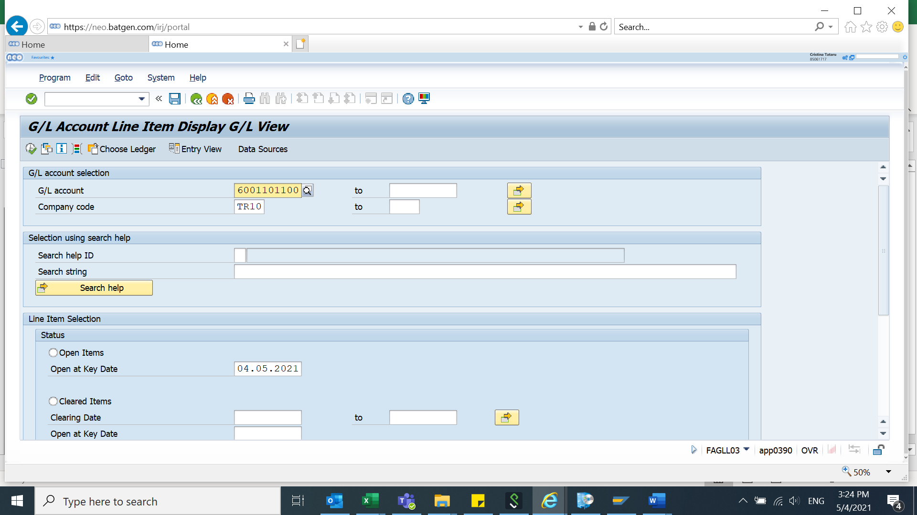



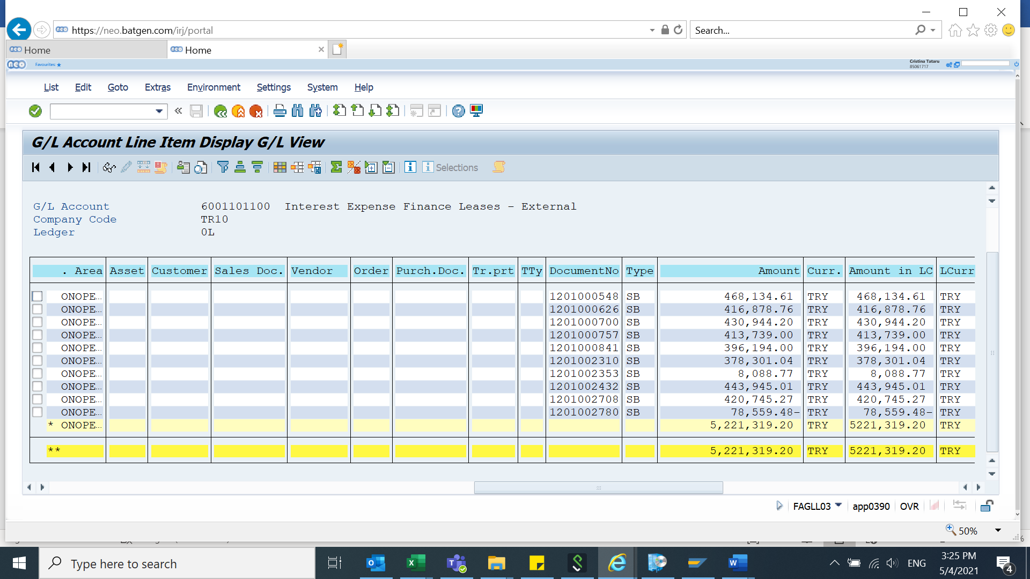

* Export the database in excel format:

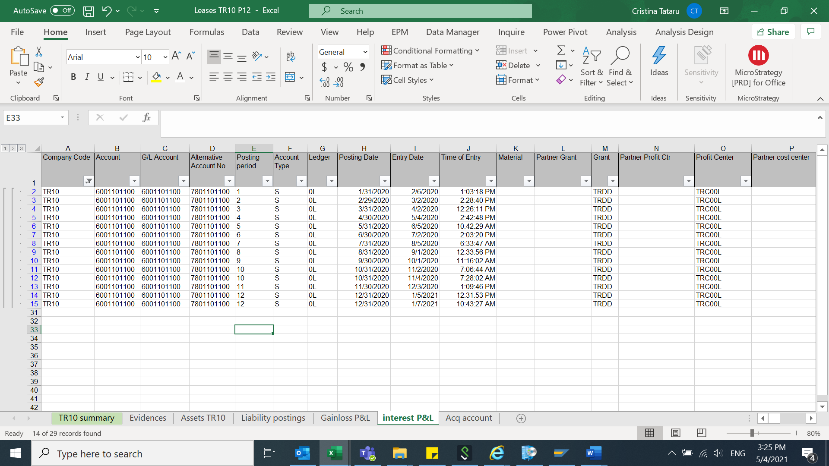

1. FAGLL03 - **Acquisition account** - ECC transaction is run as per below example:

Step 1: select Company Code (TR10)

Step 2: GL account 1190102000 Acquisition Off Setting

Step 3: select period with All items (for 2020 will be 01.01.2020-31.12.2020)

Step 4: select layout /DQI_EEMEA

Step 5: run the transaction

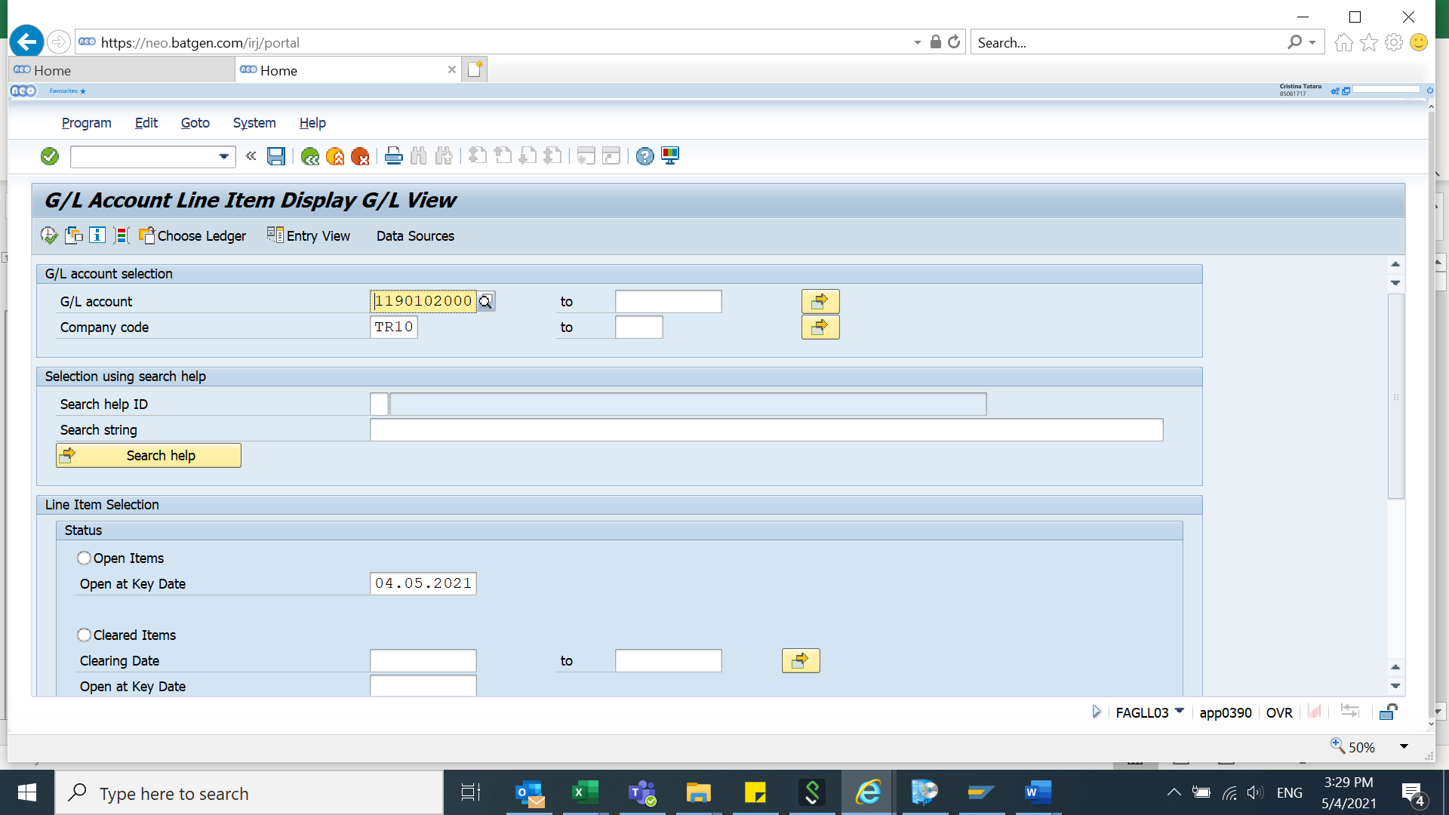



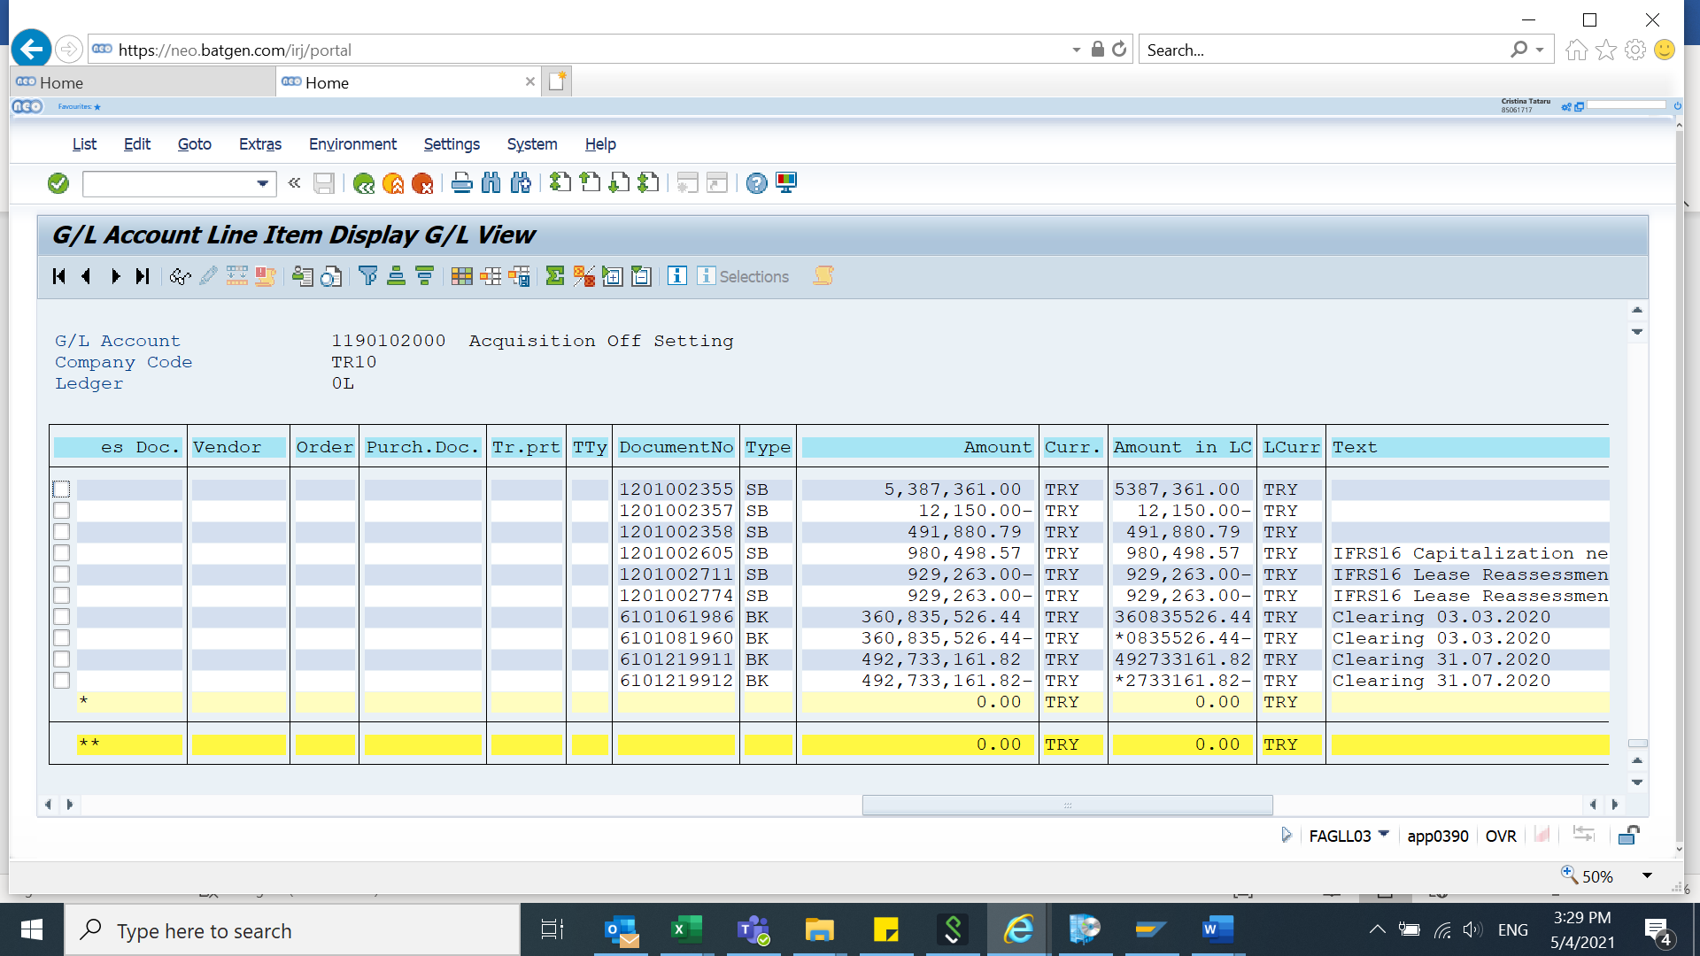

* Export the database in excel format

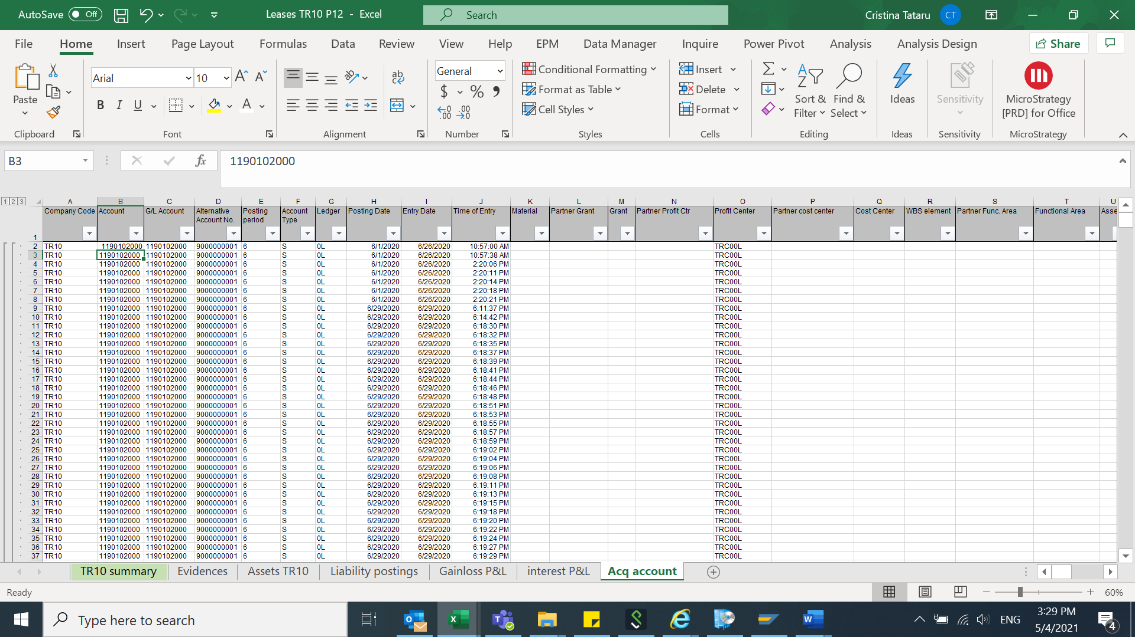

1. **TR10 summary – pivots**

After we will export all the above reports, we will summarize them in one sheet to be able to complete the input form I0032:

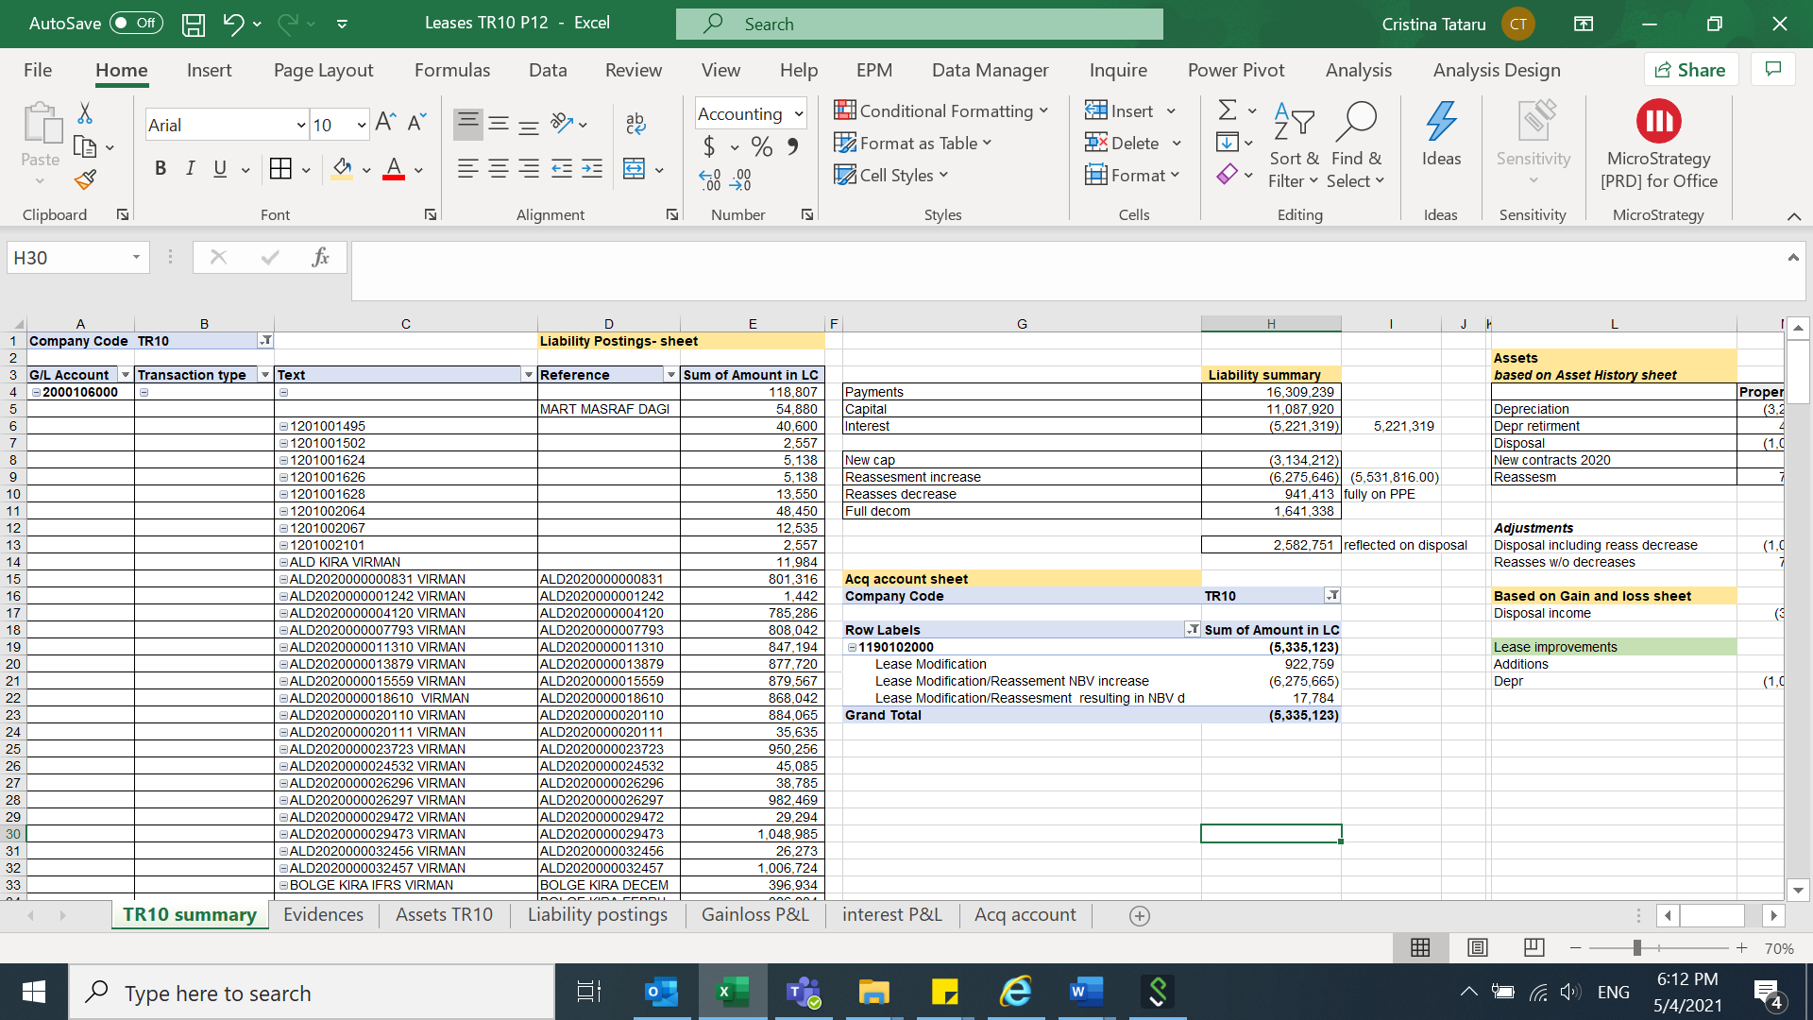

* **Liability summary:**

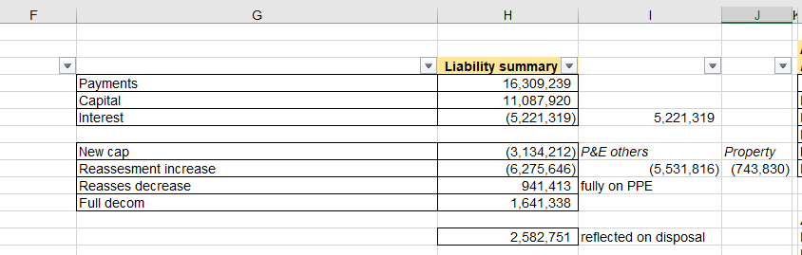

We will identify the below based on posting description:

* **Payments**

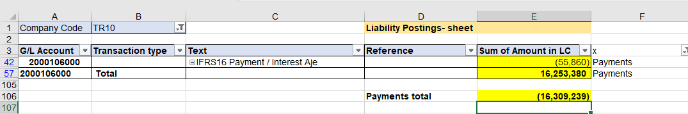

* **Capital** (will be the difference between payments and interest)

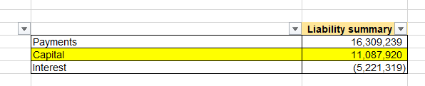

* **Interest**

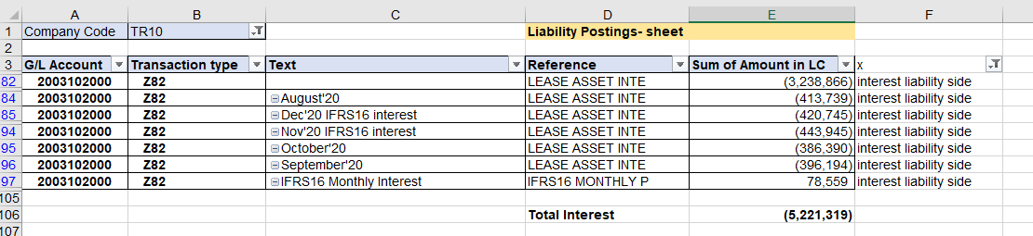

Check with P&L:

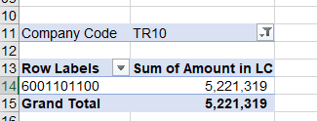

* **New capitalizations**

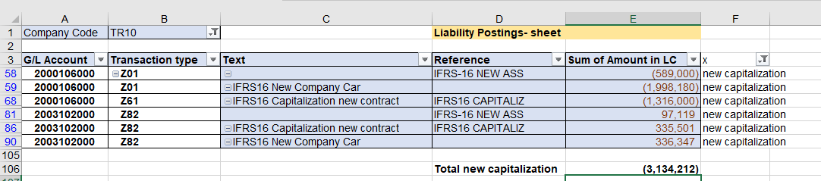

* **Reassessments** (for reassessment we take into consideration what is increase and decrease to separate them in our calculation)
* Reassessment increase:

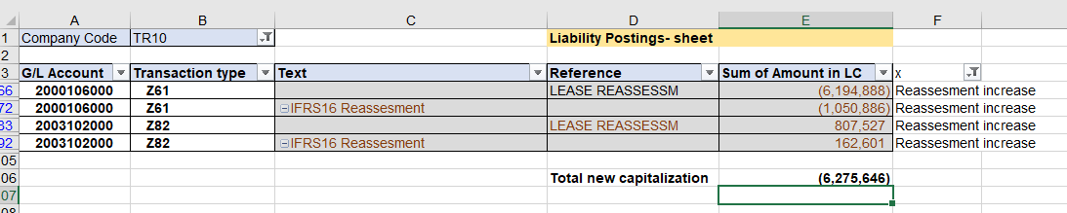

* Reassessment decrease:

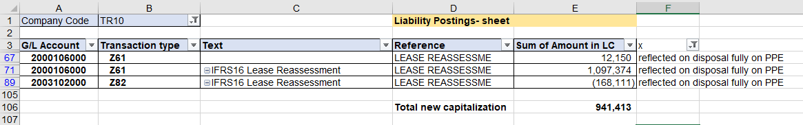

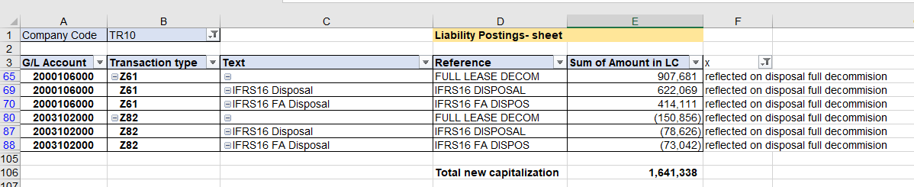

Reflected on disposal side in I0032 => will be the amount from reassessment decrease and full decommission ( 941,413+1,641,338).

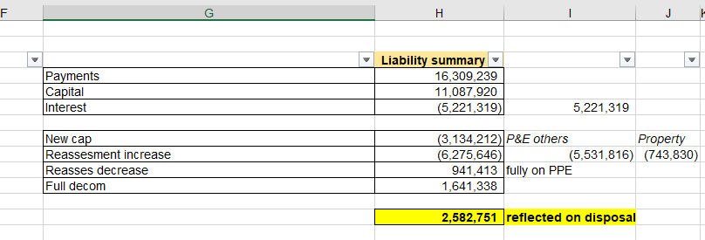

* **Assets summary based on Asset History sheet:**

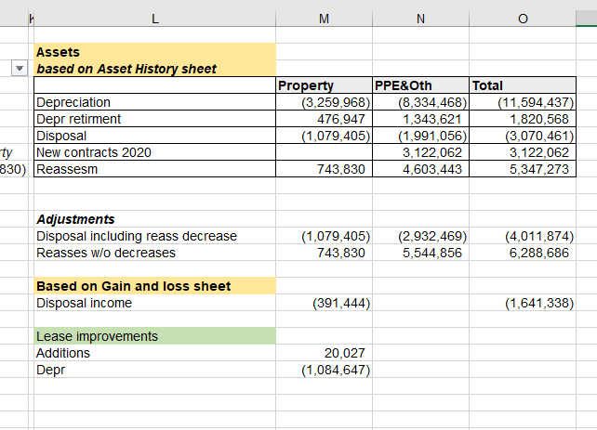

We will identify the below based on asset history sheet:

* **Depreciation:**
* Property:

From AC column we will select “Property”:

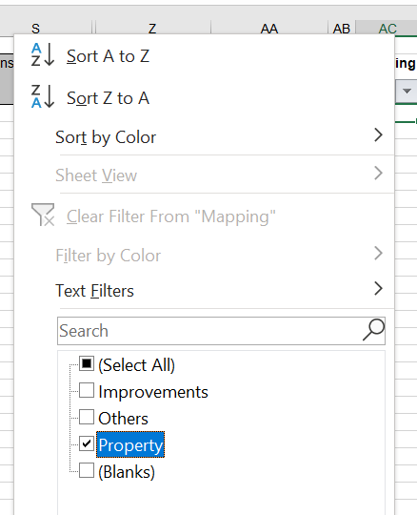

And on the column R we will see the depreciation for the year:



* PPE& Other:

From AC column we will select “Others”:

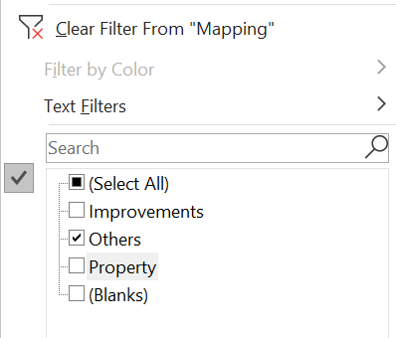

And on the column R we will see the depreciation for the year:

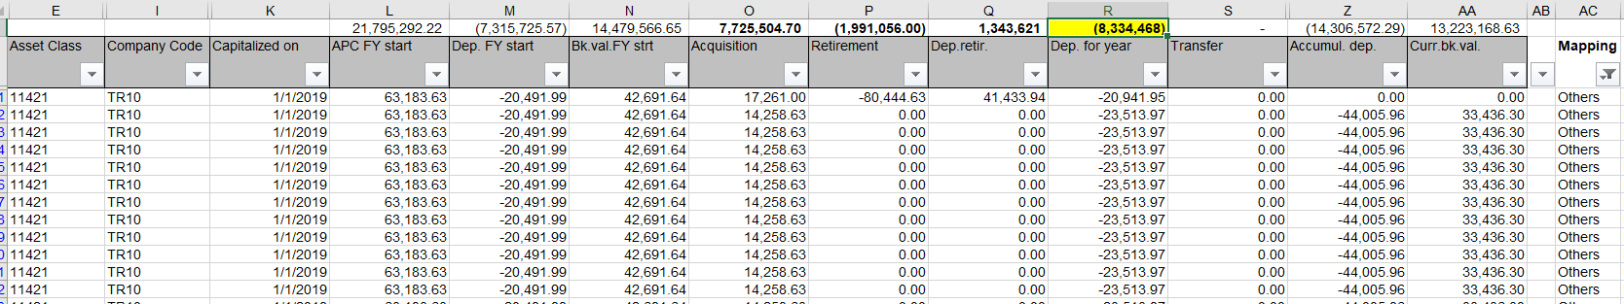

* **Depreciation retirement:**
* Property

From AC column we will select “Property” and on the column Q we will find the depreciation retirement amount:

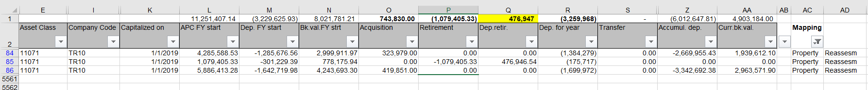

* PPE & Other

From AC column we will select “Others” and on the column Q we will find the depreciation retirement amount:

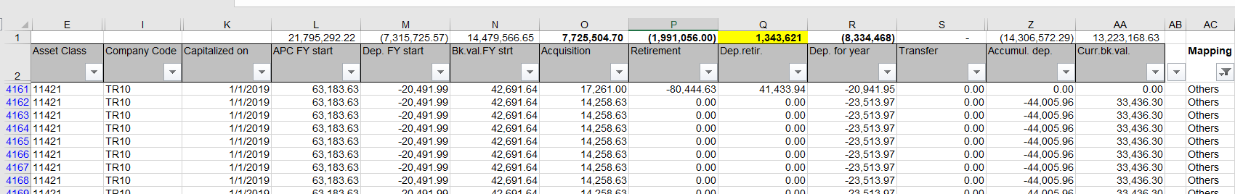

* **Disposals:**
* Property

From AC column we will select “Property” and on the column P we will find the retirement amount:

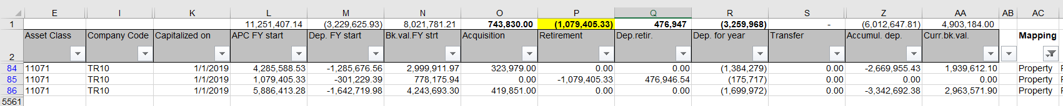

* PPE & Other

From AC column we will select “Others” and on the column P we will find the retirement amount:

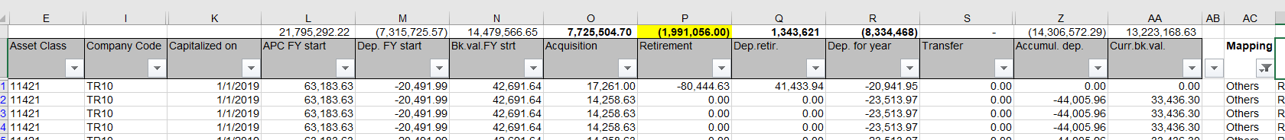

* **New contracts 2020:**
* PPE & other

From AC column we will select “Others” and from column *K- Capitalization on* we will select the year 2020 and we will find the amount on column O - Acquisition

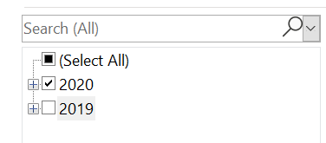

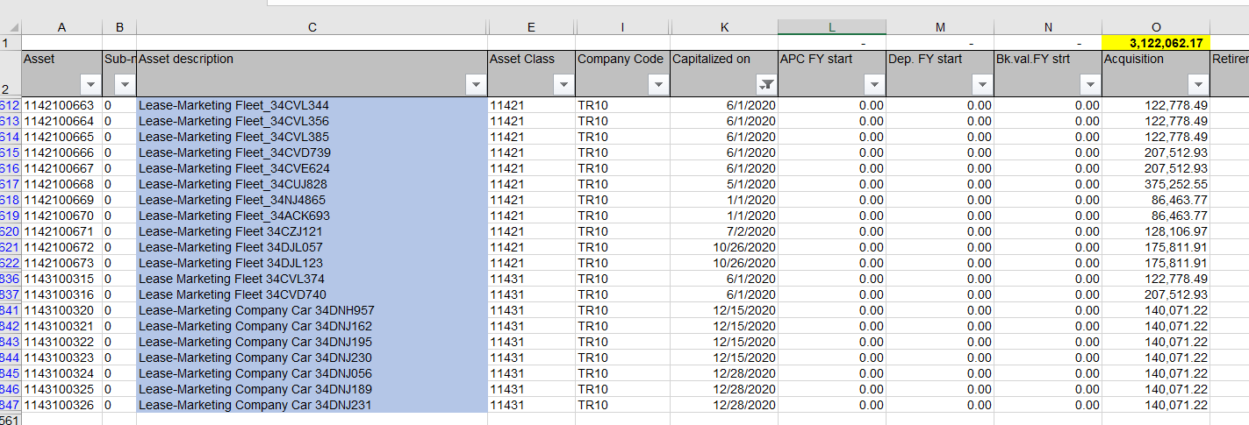

* **Reassessments**
* Property

From AC column we will select “Property” and from column K- Capitalization on we will select the year 2019 and we will find the amount on column O - Acquisition

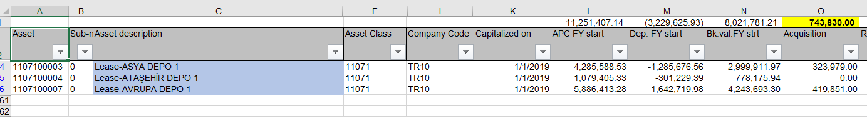

* PPE & Others

From AC column we will select “Others” and from column K- Capitalization on we will select the year 2019 and we will find the amount on column O - Acquisition

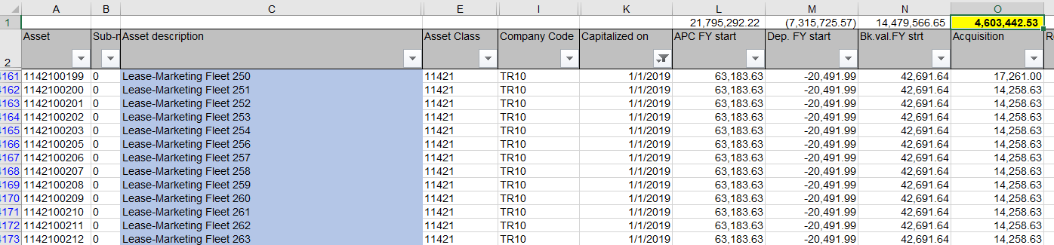

* **Adjustments:**

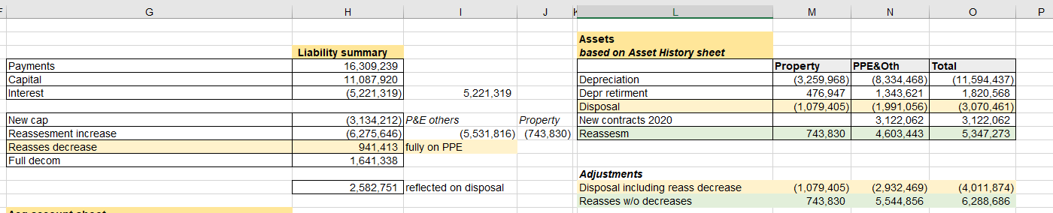

* Disposal including reassessment decrease:

For *Property* will be the amount from Disposal.

For PPE& Other- we need to take in consideration the amount from reassessment decrease (-1,991,056 - 941,413).

* Reassessment w/o decreases:

For *Property* will be the amount from Reassessment.

For PPE & Other – we need to add the amount from reassessment decrease from liability summary table (4,603,443+941,413).

* **Disposals income** (based on Gain and loss sheet):

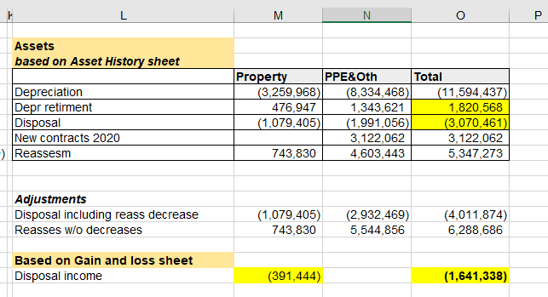

We will consider in disposals income the below amounts:

* From account 5860106100 – Gain/loss from P&L

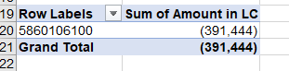

* Depreciation retirement amount 1,820,568.
* Disposal amount -3,070,561.
* **Lease improvements:**

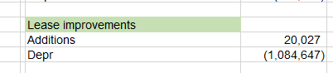

From AC column we will select “Improvements”:

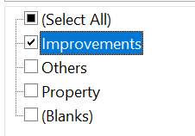

And on the column R (Dep for year) we will see the depreciation for the year (1,084,647) and from the column O (Acquisition) we can see the acquisition amount (20,027.43):

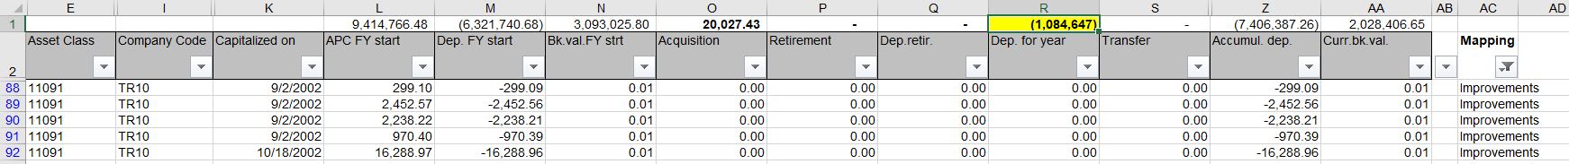

1. **I0032 - Finance Leases and Off Book Commitments:**

* Right to use assets and lease liabilities

**F20T Additions lease commitment**:

* we will input the amount from Liability summary table- new capitalization (3,134,212) on OBA69720 Leased assets (P&E, Other) and on OBA69800 Leased liabilities.





**F25A** **Depreciation or Amortization charge**:

* we will input the amount from Assets table from depreciation.



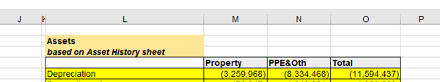

**F20V Lease reassessment increase:**

* we will input the amount from Liability summary from reassessment increase.





**F30A Decrease in asset NBV:**



* we willinput theamount from Assets table from adjustments disposal including reassessment decrease on OBA69710 - Leased Assets Property (1,079,405) and on OBA69720 - Leased Assets P&E, Other (2,932,469)



* we willinput theamount from Assets table from depreciation retirement on OBA69740 - Accumulated Depreciation and Impairment Property (476,747) and on OBA69750 - Accumulated Depreciation and Impairment P&E, Other(1,343,621)

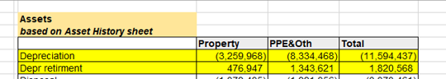

* we willinput theamount from Liability summary table reflected on disposal (2,582,751) on OBA69800 - Lease Liabilities (within borrowings)

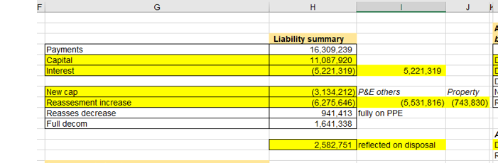

**F30K – Interest & F30J Capital:**

* we will input the amounts from Liability summary table capital and interest



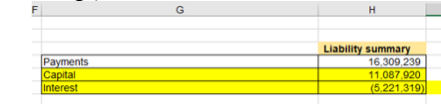



**Leased improvements**



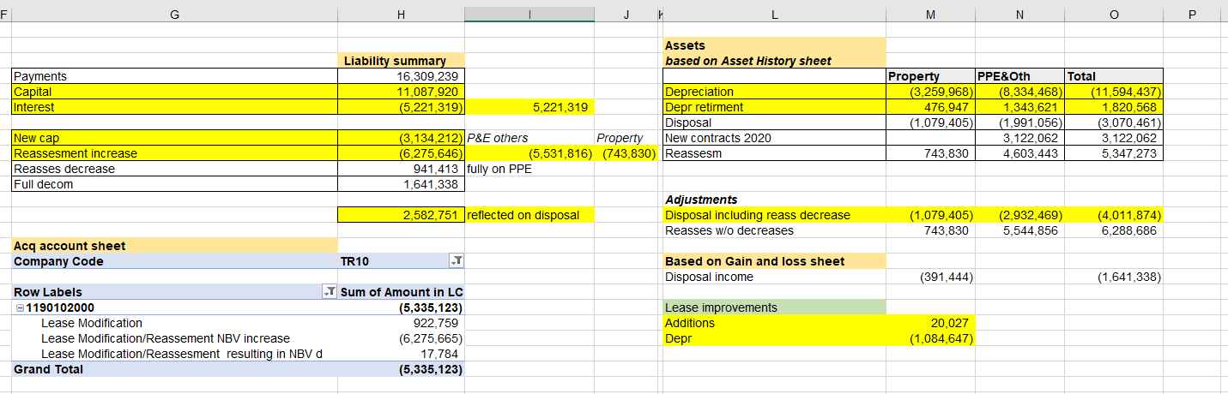

* Additional disclosure leases
* For the below questions we need the EM help to input the correct answers.
* For NBV of the right to use assets we will input the amount from Right to use assets and lease liabilities from OBA69700 - Net leased assets.



* For leases with variable payments we will input the amount from Lease summary table – payments:



